**CASE B :**

**PROBLEM 1 :**

**TURBOFAN WITH FAN EXHAUSTED AND WITHOUT A TURBOFAN :**

**CODE :**

%Programming Assignment

%Case :B -> Turbofan without a after burner

%case B: Problem 1

% NAME : BARU RAVI VARMA

% ROLL NO: 14AE10007

%%ASSUMPTIONS : GAMMA VALUE IS CONSTANT AND EQUAL TO 1.4

%%CODE

clc;

clear all;

%Given'

Ma = 0.75;

r = 1.4;

f = 4.0;

P = 5.78; %Tt4/Ta

Q = 1+ ((r-1)/2) * Ma * Ma;

i = 1;

for FPR = 1.5 :0.25: 3%Fan Presuure Ratio

for CPR = 5 :5: 25 % Compressure Pressure Ratio

FTR = FPR.^((r-1)/r);

CTR = CPR.^((r-1)/r);

l = ((CTR-1)+f*(FTR-1));

m = (Q*CTR*(1-(Q/P)*l)-1);

nr = P*m/(Q*CTR);

n = nr/(Q-1);

S1 = sqrt(n) -1;

s2 = f * (sqrt((Q*FTR-1)/(Q-1)) - 1);

NDT(i) = Ma * (S1+s2)/(1+f);

i = i+1;

end

end

%NDT(21) =

NDT

h = 1;

for j = 1.5 : 0.25 : 3

for k = 5 : 5 : 25

FPR(h) = j;

CPR(h) = k;

h= h+1;

end

end

FPR;

CPR;

figure

[x,y] = meshgrid(CPR,FPR);

z = griddata(CPR,FPR,NDT,x,y,'linear');

mesh(x,y,z);

axis tight; hold on;

plot3(x,y,z,'o')

xlabel('Compressor Pressure Ratio');

ylabel ('Fan Pressure Ratio');

zlabel ('Dimensionless Thrust');

**GRAPH** :

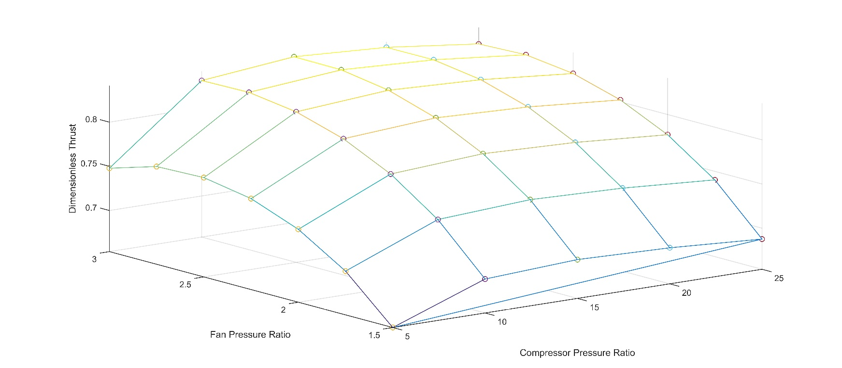SIMPLE PLOT :

SURFACE PLOT WITH CURVE FITTING :

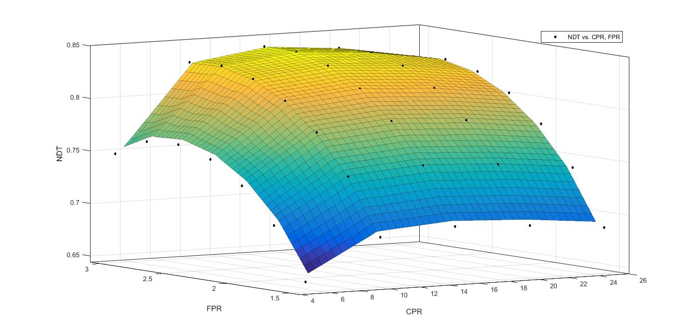

**ANALYSIS :**

1) In this assignment we are finding the variation of Non dimensional thrust against Compressor Pressure Ratio and Fan pressure ratio by a 3Axis plot.

2) we know that Dimensionless thrust depends on Compressor and fan temperature ratios which in turn depend on Compressor Pressure Ratio and Fan pressure ratio respectively and we have the relation :

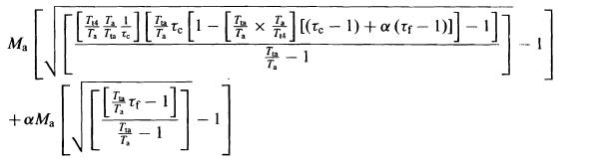F/mtaa=( )/(1+α)

Where mt : Total mass flow rate = m(1+α)

3) From the graph we can infer that non dimensionalised thrust gets increased as the Fan pressure ratio is increased and non dimensionalised thrust increased as compressure pressure ratio gets increased ; upto a certain amount in both the cases and later on gets decreased in both the cases forming an semi spherical like surface .

4) Assumptions :

a) The first part under the square root in the equation is getting negative for Fan pressure ratio 4.0 so we are neglecting that value and for 0 compressor pressure ratio we cannot find the values so we are removing 0 also.

b) ) Value of γ = 1.4 and is constant through out.

C) since step size is not provided I have assumed the Fan pressure ratio in steps of 0.25 and compressor pressure ratios in steps of 5.